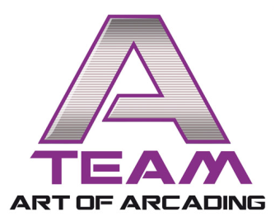

SUPERGUN
ARCADE ENTERTAINMENT SYSTEM MODEL 2P4

Thank you for purchasing the Arcade-Team Supergun Model 2P4. This Arcade Entertainment system allows playing Arcade hardware and Arcade PCBs with Jamma connection on TVs equipped with Scart connector.

OVERVIEW:
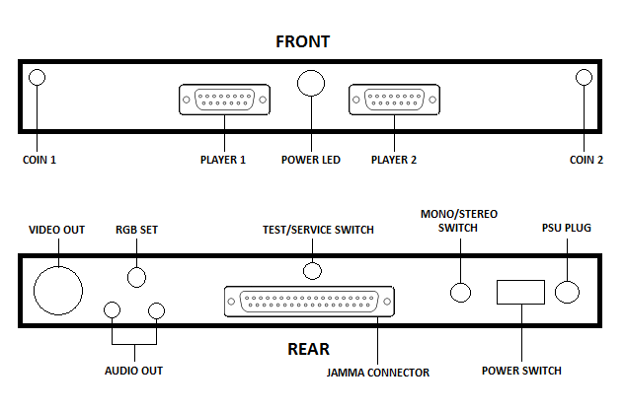
Others :
- Power supply unit
- Scart cable
- Jamma cable
Neo Geo Controllers (AES and CD – not provided) are compatible with the ATeam Supergun.
INSTRUCTIONS:
- Make sure the power switch is OFF,
- Connect the Scart cable to the Supergun,
- Connect the PSU to the Supergun,
- Connect the Jamma cable to the Jamma connector of the Supergun,
- Connect your Arcade game to the over end of the Jamma cable, make sure to connect the Arcade game in the correct way (see “part side” and “solder side” on the Jamma cable),
- Connect the other end of the Scart cable to the TV,
- Connect the PSU to home electrical socket,
- Connect the Neo Geo controllers to Player 1 and 2 sockets,
- Turn the power switch ON; the power LED lits,
- Press COIN 1 or COIN 2 to add credits,
- Pressing Test or Service will provide Test and Service menus; please refer to your Arcade game manual to see the game settings,
- Move the “RGB Set” potentiometer to adjust colors saturation if necessary.

MISCELLENOUS:
- Make sure to turn the power OFF and unplug the PSU before opening the Supergun,
- Always make sure that the Supergun is turned OFF when removing your Arcade game,
- Be sure to take an occasional recess during extended play.

